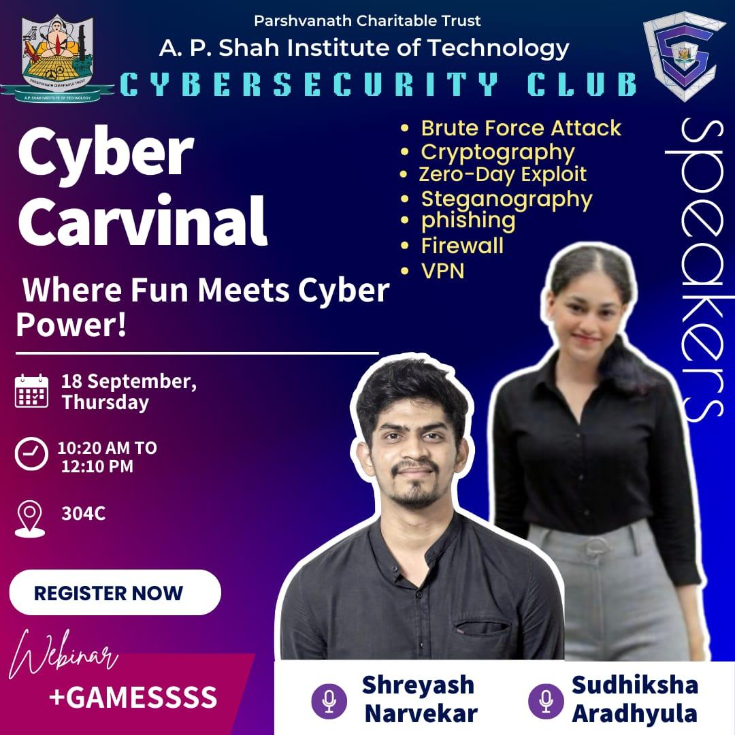

Session: Cyber Carnival – Where Fun Meets Cyber Power!

Name of College: A. P. Shah Institute of Technology, Kasarvadavali, Ghodbunder Road, Thane – 400615
Date: 18/09/2025
Venue: 304-C
Participants:
Targeted Audience: Students Interested in Cybersecurity learning domain from IT, CS, DS, AIML Department.
Speaker:
- Shreyash Narvekar (Technical head)
- Sudhiksha Aradhyula (Mentor)

Faculty Accompanied:

Prof. Sneha Dalvi

Prof. Randeep Kaur Kahlon

Prof. Saylee Lapalikar

Prof. Manjusha Kashilkar.

Organizers:
Cybersecurity Club, A. P. Shah Institute of Technology

Aim of Event: The Cyber Carnival was organized with the objective of promoting cybersecurity awareness among students and equipping them with practical knowledge to safeguard themselves in the digital domain.

The Cyber Security Club of A. P. Shah Institute of Technology organized the Cyber Carnival, an event designed to provide both technical knowledge and interactive learning opportunities in the field of cybersecurity.

The event commenced with an enlightening session by Ms. Sudhiksha Aradhyula, who elaborated on core cybersecurity concepts. Topics included the use of VPNs for secure browsing, brute-force attacks and the significance of strong passwords, cryptography and steganography as methods of securing communication, and zero-day exploits with an emphasis on the necessity of timely software updates. This was followed by an insightful presentation by Mr. Shreyas Narvekar, who focused on phishing attacks. He explained their objectives, highlighted common red flags such as urgency and suspicious links, and discussed preventive strategies, supported with relevant real-life examples.

To encourage student participation and reinforce the knowledge shared during the sessions, a series of interactive activities were conducted, including Phishing Email Hunt, Pictionary, Cyber Bingo, Emoji Cyber Quiz, and Word Scramble. These activities were effectively coordinated by student volunteers — Alok and Arsh, Sanchit and Sejal, Siddharth and Tanushree, Prisha and Vaibhavi, and Mahi and Ketkee. Their efforts ensured smooth execution and enthusiastic involvement from all participants.

The Carnival concluded with the declaration of winners of the overall games:

First Prize – Team “405 Found” comprising Patil Mihika, Palrecha Anchita, Patil Nisarga, and Mulundkar Daksh

Second Prize – Team “Two Factor” comprising Abbas Sangmeshwari and Anchita Patekar

These teams were commended for their teamwork, problem-solving skills, and active participation.

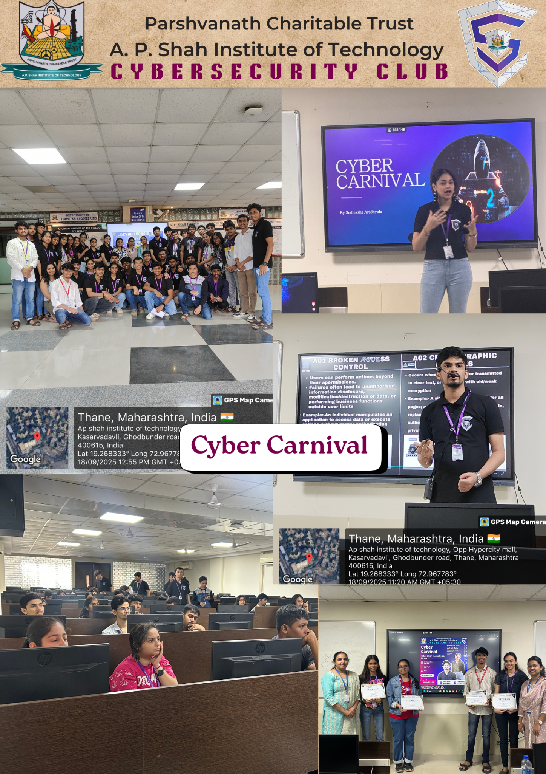
The Cyber Carnival proved to be a highly enriching event that successfully combined technical insights with engaging activities. It significantly enhanced students’ understanding of cybersecurity practices, encouraged vigilance against cyber threats, and inspired them to contribute towards creating a safer and more secure digital ecosystem.

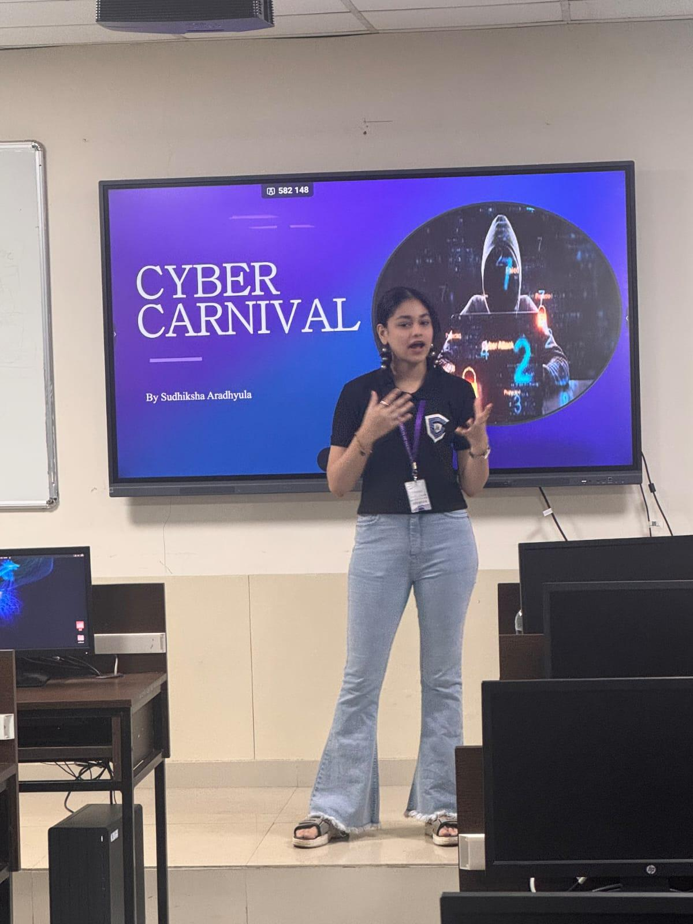
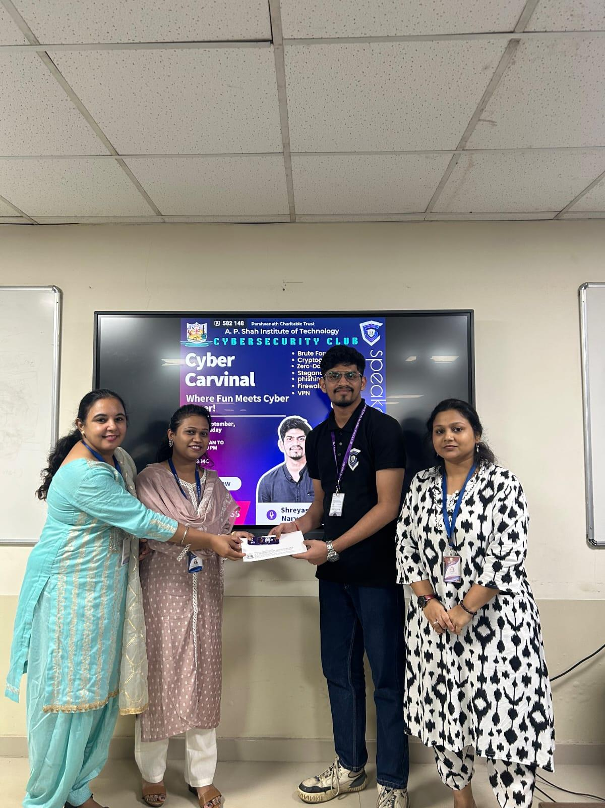
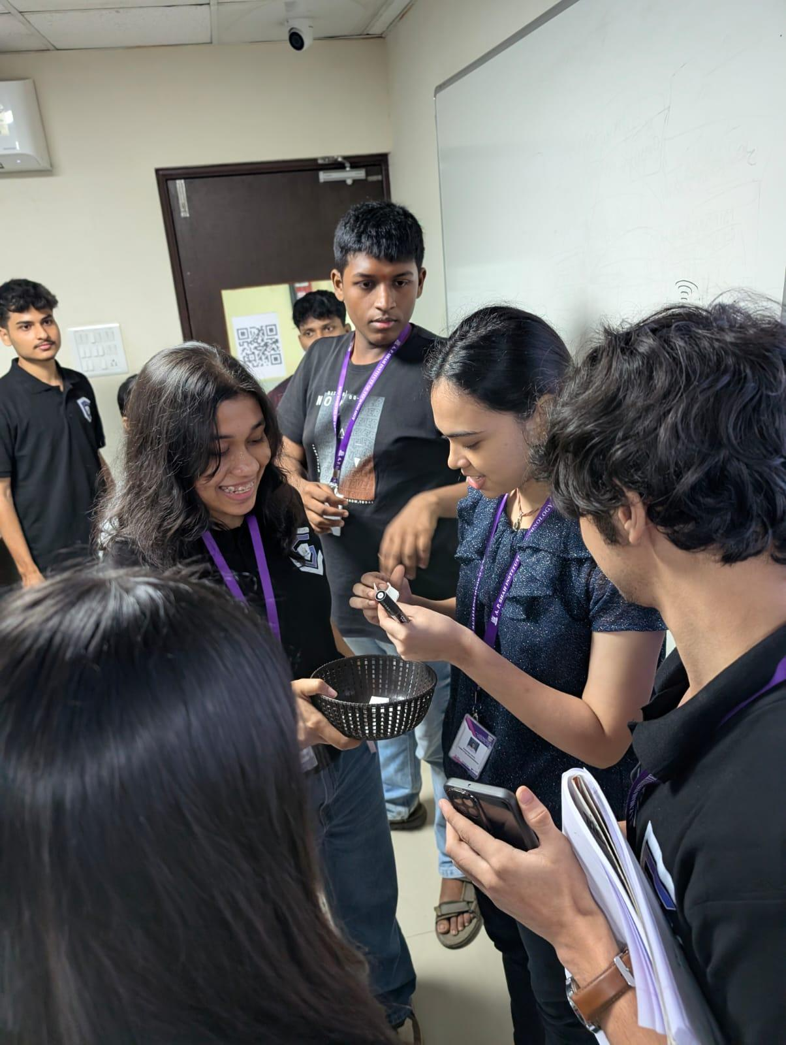
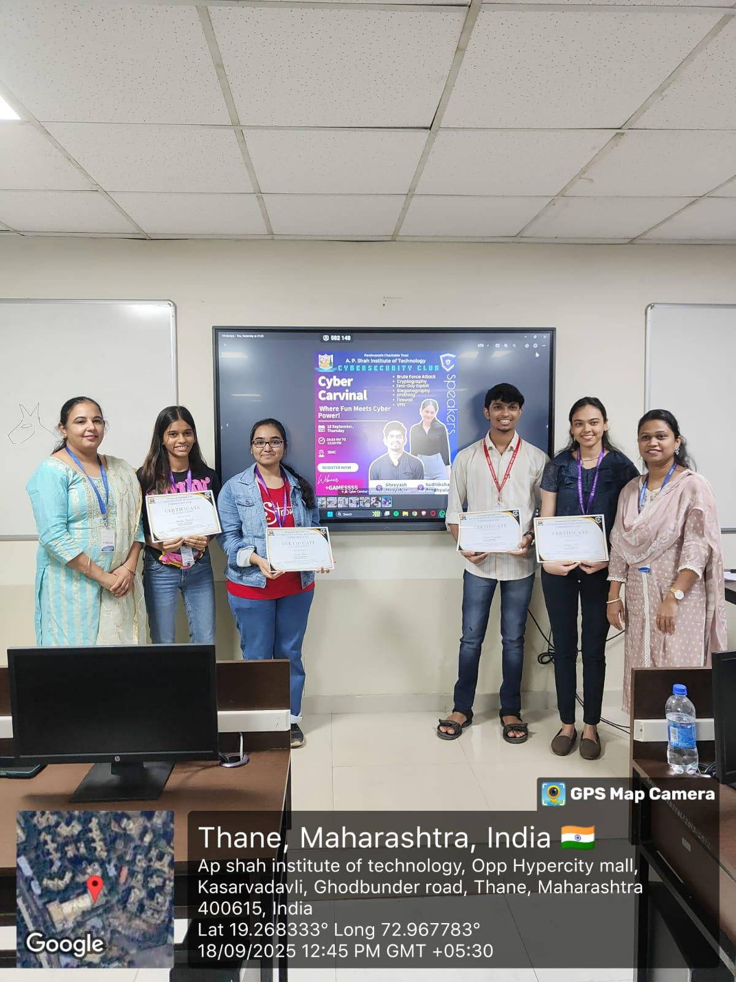
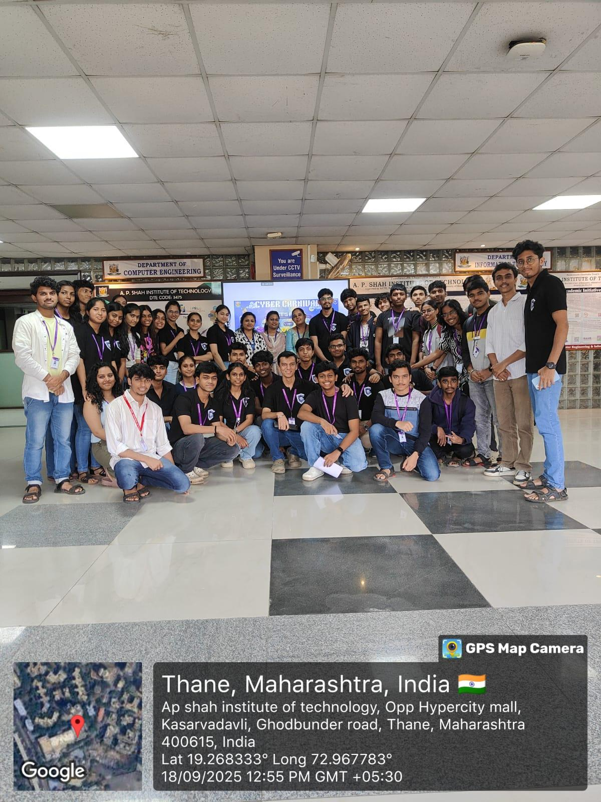
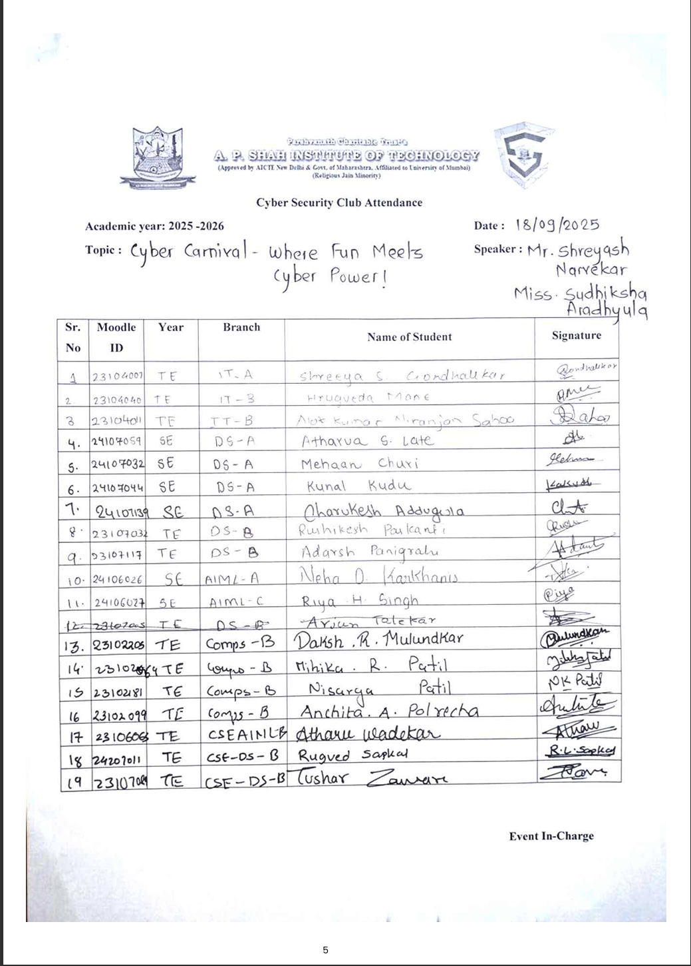
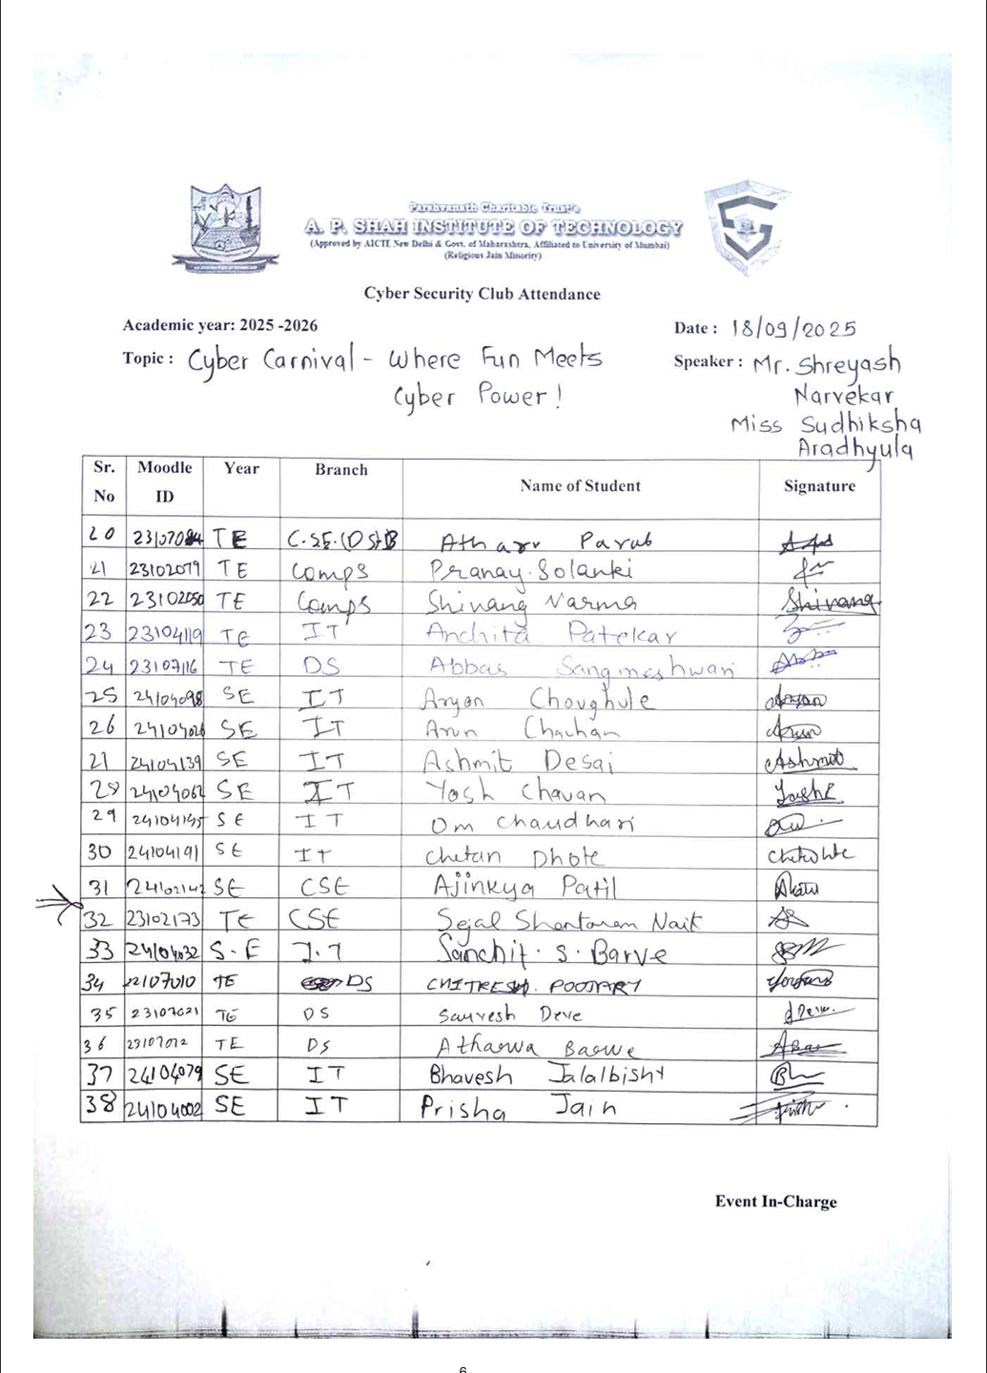
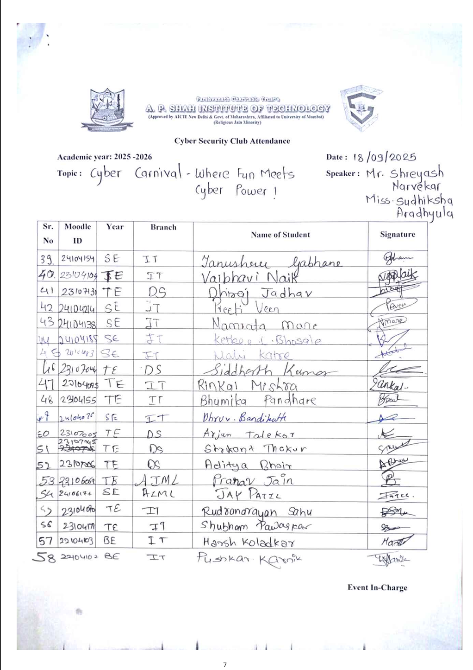
Feedback Form Analysis:
